**Characteristics of the Database Approach**

In the database approach, a single repository maintains data that is defined once and then accessed by various users repeatedly through queries, transactions, and application programs.

The main characteristics of the database approach versus the file-processing approach are the following:

■ Self-describing nature of a database system

■ Insulation between programs and data, and data abstraction

■ Support of multiple views of the data

■ Sharing of data and multiuser transaction processing

**Self-Describing Nature of a Database System**

A fundamental characteristic of the database approach is that the database system contains not only the database itself but also a complete definition or description of the database structure and constraints.

This definition is stored in the DBMS catalogue, which contains information such as the structure of each file, the type and storage format of each data item, and various constraints on the data. The information stored in the catalogue is called meta-data, and it describes the structure of the primary database.

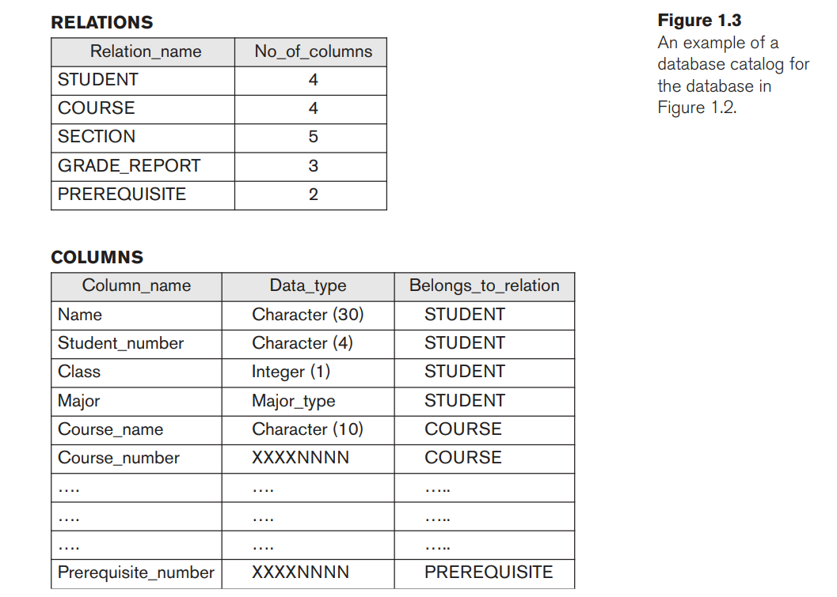

**Insulation between Programs and Data, and Data Abstraction**

The structure of data files is stored in the DBMS catalogue (a complete list of items) separately from the access programs. We call this property program-data independence.

An operation (also called a function or method) is specified in two parts. The interface (or signature) of an operation includes the operation name and the data types of its arguments (or parameters). The implementation (or method) of the operation is specified separately and can be changed without affecting the interface.

User application programs can operate on the data by invoking these operations through their names and arguments, regardless of how the operations are implemented. This may be termed program-operation independence.

The characteristic that allows program-data independence and program-operation independence is called data abstraction.

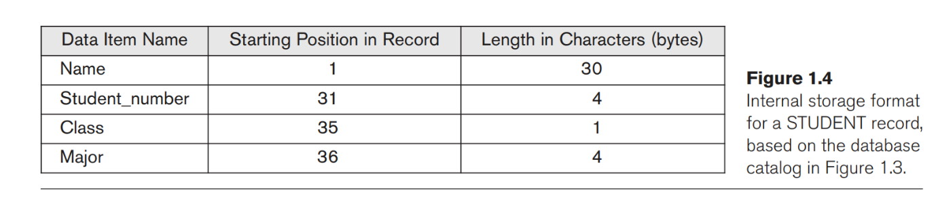

**Support of Multiple Views of the Data**A database typically has many types of users, each of whom may require a different perspective or view of the database. A view may be a subset of the database or it may contain virtual data that is derived from the database files but is not explicitly stored.

For example, one user of the database may be interested only in accessing and printing the transcript of each student.

A second user, who is interested only in checking that students have taken all the prerequisites of each course for which the student registers.

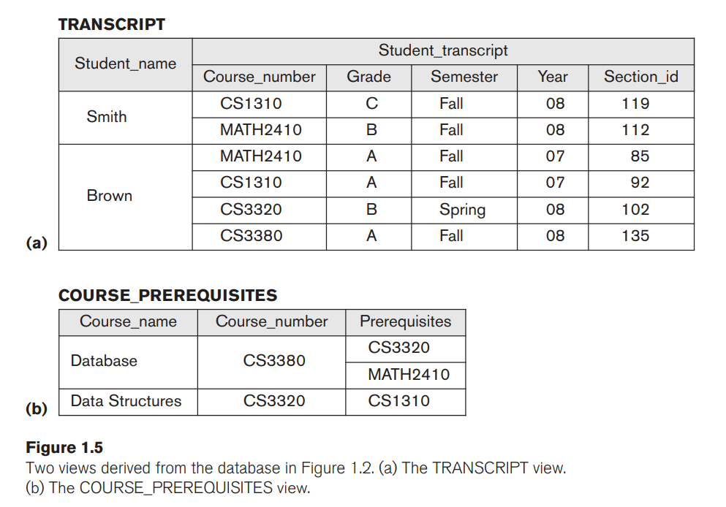

**Sharing of Data and Multiuser Transaction Processing**

A multiuser DBMS, as its name implies, must allow multiple users to access the database at the same time. This is essential if data for multiple applications is to be integrated and maintained in a single database.

For example, when several reservation agents try to assign a seat on a flight, the DBMS should ensure that each seat can be accessed by only one agent at a time for assignment to a passenger. These types of applications are generally called online transaction processing (OLTP) applications. A fundamental role of multiuser DBMS software is to ensure that concurrent transactions operate correctly and efficiently.